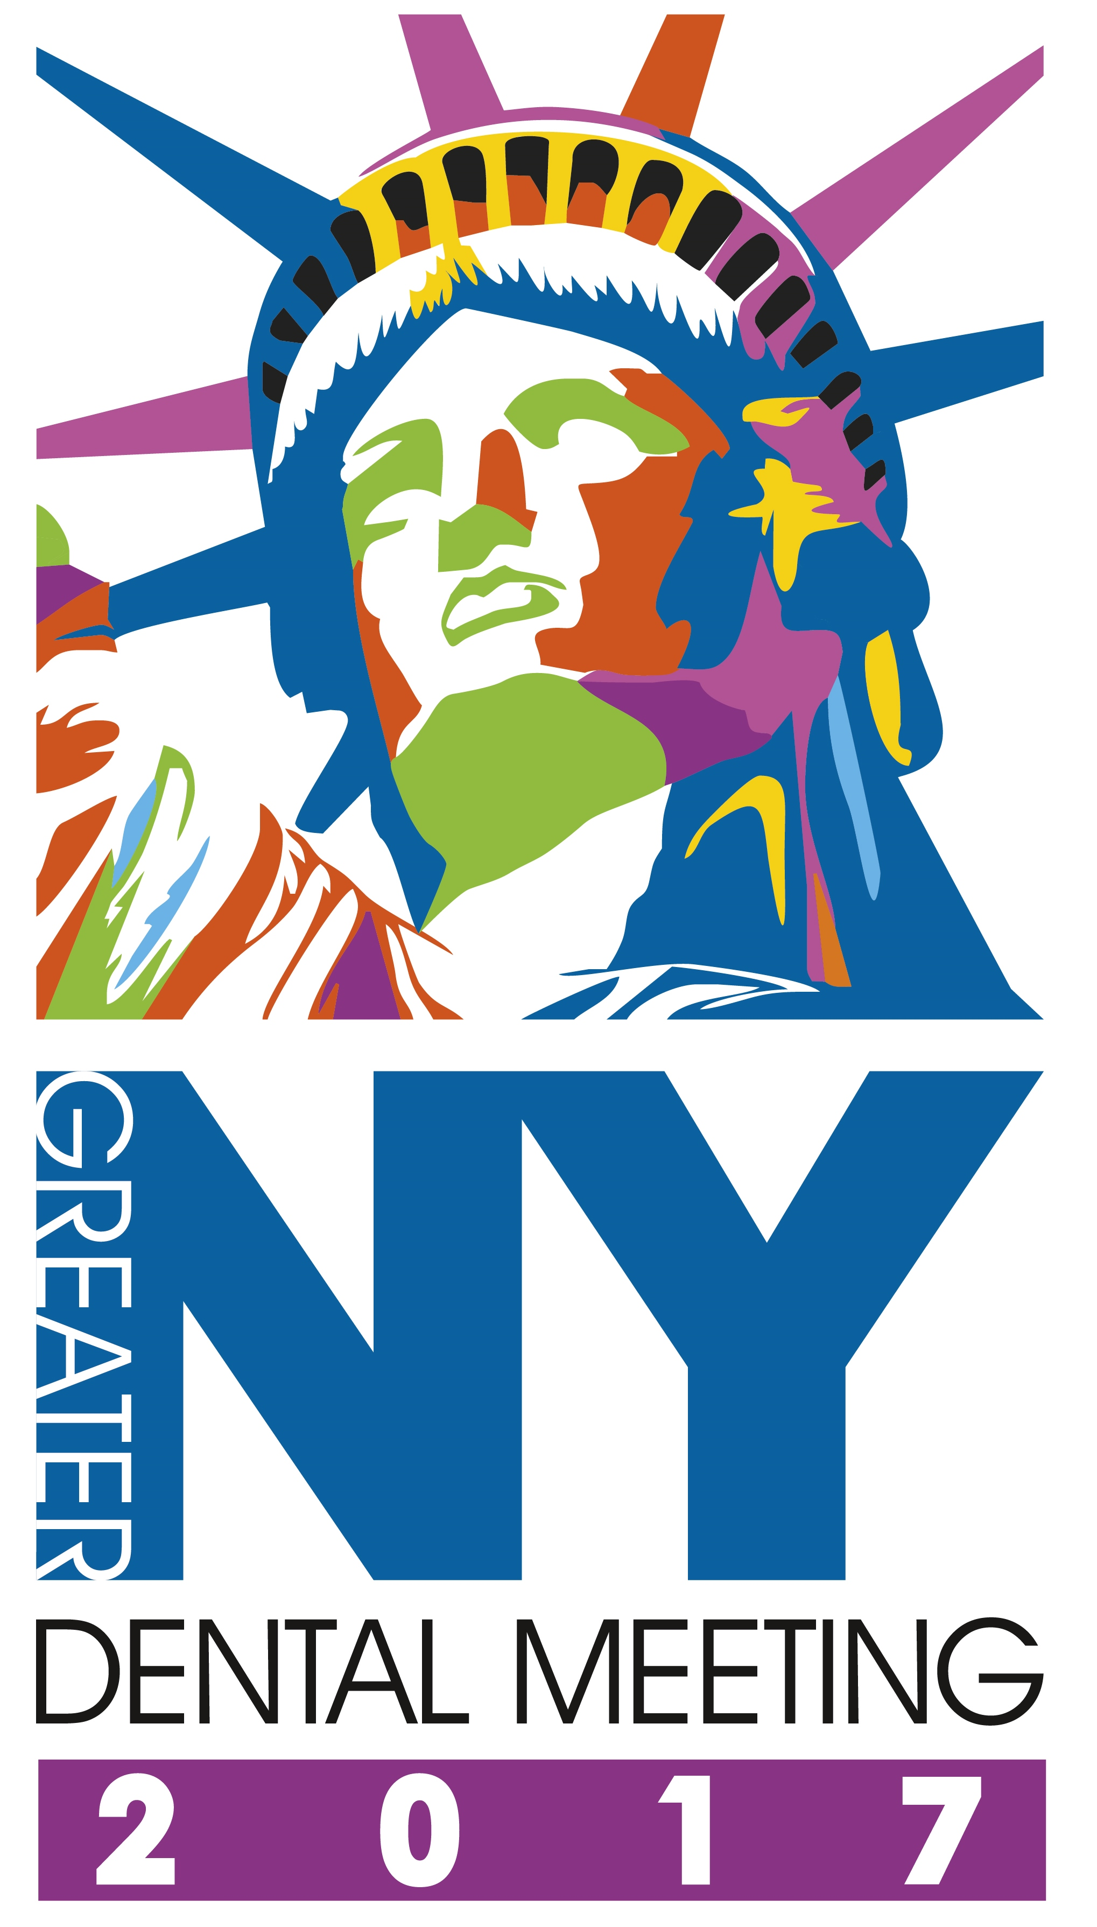
Greater New York Dental Meeting
200 W. 41st Street, Suite 800
New York, NY 10036
F: (212) 398-6934 / E-mail: Carla@gnydm.com
www.gnydm.com
One Time Credit Card Payment Authorization Form

Sign and complete this form to authorize Greater New York Dental Meeting to make a one time debit to your credit card listed below.

By signing this form you give us permission to debit your account for the amount indicated on or after the indicated date. This is permission for a single transaction only, and does not provide authorization for any additional unrelated debits or credits to your account.

Exhibiting Company:

Please complete the information below:

I ____________________________ authorize GREATER NEW YORK DENTAL MEETING to charge my credit card
(full name)
account indicated below for _____________ on or after ___________________. This payment is for deposit/final
(amount) (date)

payment/sponsorship and/ or advertising.

Exhibit Space at 93rd Annual Session.
(description of goods/services)

Billing Address ____________________________ Phone# ________________________
City, State, Zip ____________________________ Email ________________________

Account Type: Visa MasterCard AMEX
Cardholder Name _________________________________________________
Account Number _____________________________________________
Expiration Date ____________
CVV2 (3 digit number on back of Visa/MC, 4 digits on front of AMEX) ______
SIGNATURE DATE

I authorize the above named business to charge the credit card indicated in this authorization form according to the terms outlined above. This payment authorization is for the goods/services described above, for the amount indicated above only, and is valid for one time use only. I certify that I am an authorized user of this credit card and that I will not dispute the payment with my credit card company; so long as the transaction corresponds to the terms indicated in this form. I also understand there will be a 3% convenience fee added to my total amount.

