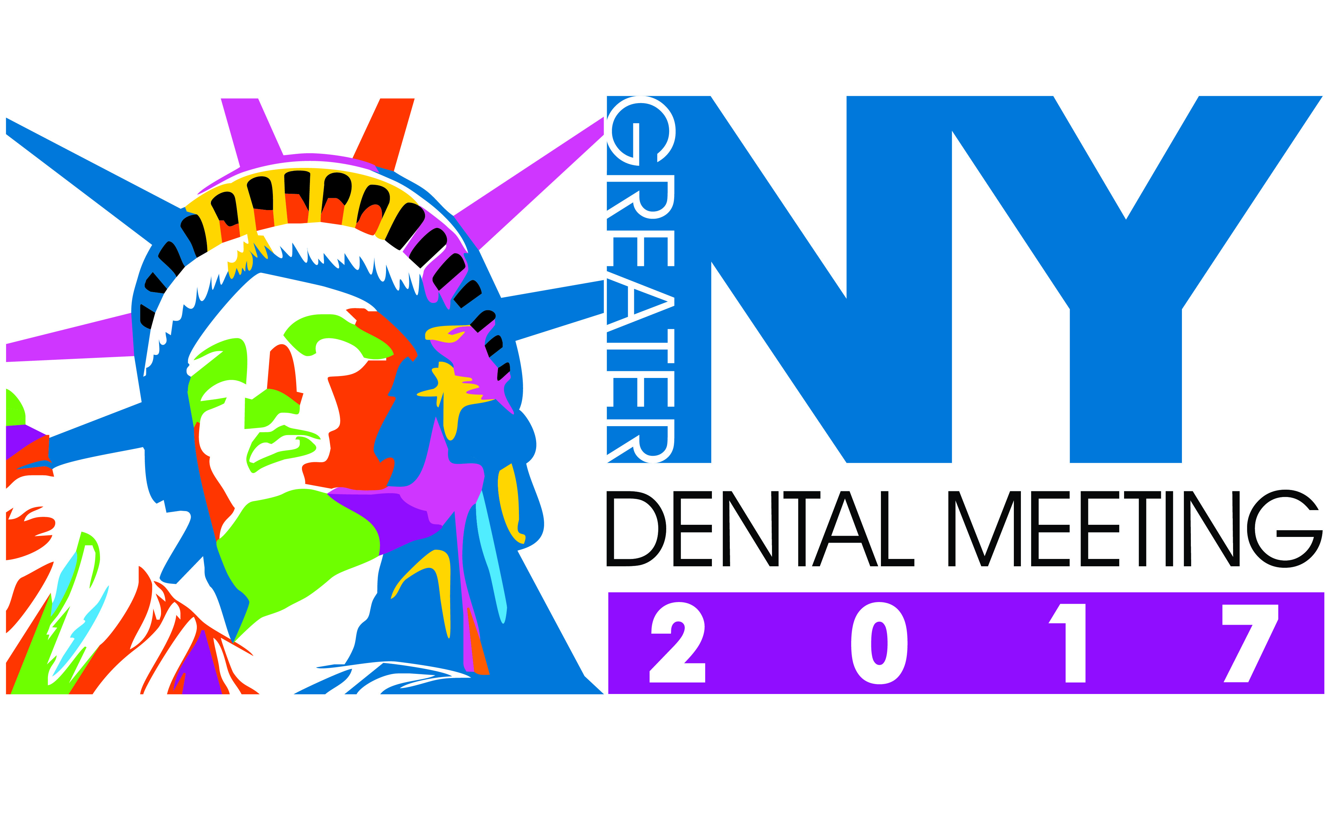
Volunteer Appreciation
Dinner Form

⁭□ YES I will be attending the Volunteer Appreciation Dinner on Tuesday, November 21, 2017 at the Marriott Marquis Hotel at 6:00pm.

□ NO I will not be attending the Volunteer Appreciation Dinner on Tuesday, November 21, 2017 at the Marriott Marquis Hotel at 6:00pm.

My Choice of Dinner is:

□ CHICKEN □ FISH □ VEGETARIAN

□ KOSHER □ GLUTEN FREE

PLEASE PRINT CLEARLY.

First Name: Last Name:

Address:

City: State: Zip:

Telephone:

Email:

Number of Years Volunteering for GNYDM:

Please fax form to (212) 398-6934 or email to Tisha@gnydm.com, or mail to

Greater New York Dental Meeting, 200 W 41st Street, Suite 800, New York, New York 10036

